1. Syntax – echo

Description - Output any text that we provide

Example –

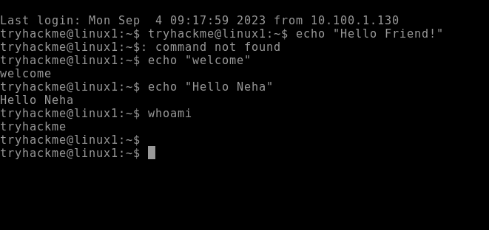

1. Syntax – whoami

Description - Find out what user we're currently logged in as!

Example –



1. Syntax – ls

Description - listing

Example –

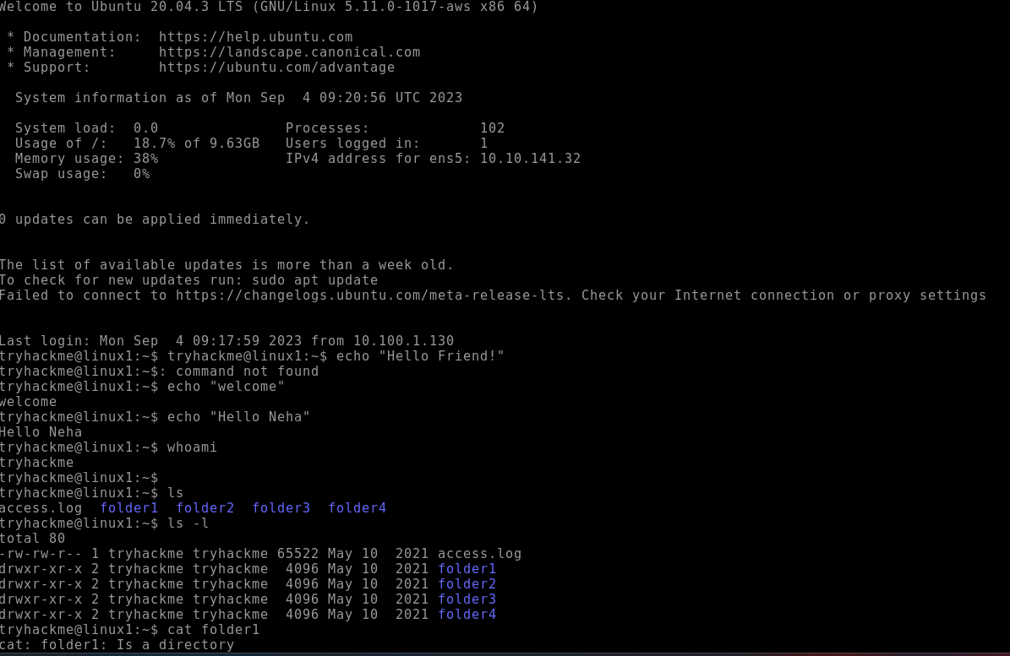

3(b) Syntax – Ls -l

Description -

Example –

1. Syntax – cd

Description - change directory

Example –

1. Syntax – cat

Description - concatenate

Example –

1. Syntax – Pwd

Description -

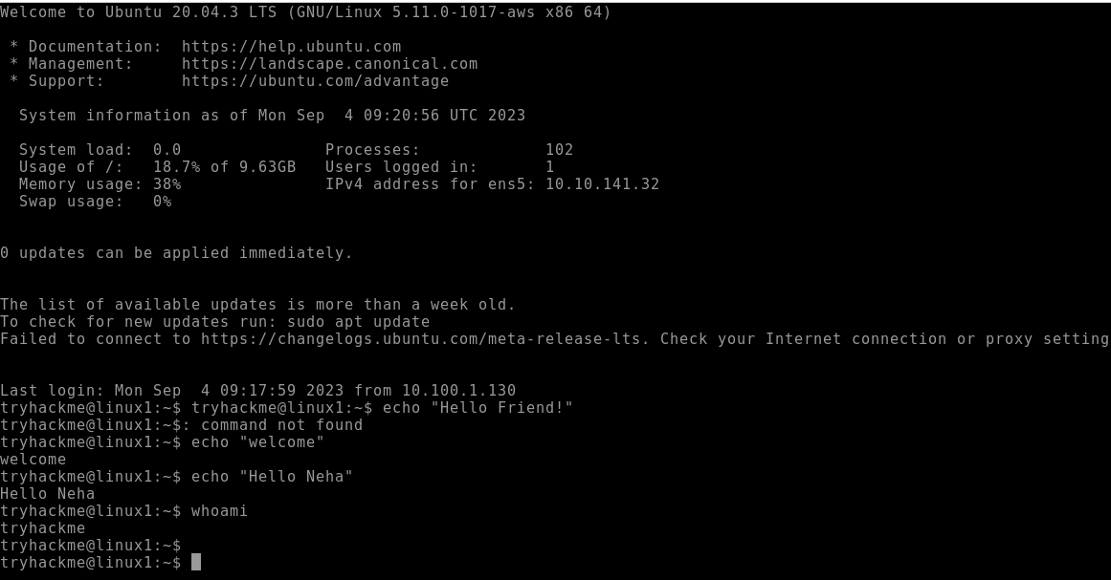

C:\Users\student\Pictures\Screenshots\Screenshot 2023-09-04 145917.png

